Packet Tracer – Implementing Static and Dynamic NAT

1. Topology

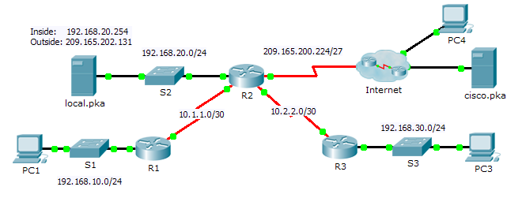

1. Objectives

Part 1: Configure Dynamic NAT with PAT

Part 2: Configure Static NAT

Part 3: Verify NAT Implementation

1. Configure Dynamic NAT with PAT
   1. Configure traffic that will be permitted for NAT tranlations.

On **R2**, configure a standard ACL named **R2NAT** that uses three statements to permit, in order, the following private address spaces:192.168.10.0/24, 192.168.20.0/24, and 192.168.30.0/24.

* 1. Configure a pool of addresses for NAT.
     1. Configure **R2** with a NAT pool that uses the first two addresses in the 209.165.202.128/30 address space. The fourth address is used for static NAT later in Part 2.
  2. Associate the named ACL with the NAT pool and enable PAT.
  3. Configure the NAT interfaces.

Configure **R2** interfaces with the appropriate inside and outside NAT commands.

1. Configure Static NAT

Refer to the Topology. Create a static NAT translation to map the **local.pka** inside address to its outside address.

1. Verify NAT Implementation
   1. Access services across the Internet.
      1. From the web browser of **PC1**, or **PC3**, access the web page for **cisco.pka**.
      2. From the web browser for **PC4**, access the web page for **local.pka**.
   2. View NAT translations.

View the NAT translations on **R2**.

R2# **show ip nat translations**